Rotary Club of Kathmandu Mid-Town
Breakfast Chatter




17 February 2012 The Weekly Bulletin of Rotary Club of Kathmandu Mid-Town Bc-2.17/011-12

District: 3292 Web: www.rotarymidtown.org.np Club Id : 26776

FEBRUARY IS WORLD UNDERSTANDING MONTH
Advancing world understanding and peace, which is expressed in the fourth part of the Object of Rotary,
is an important focus of Rotarian service. It is the impetus for numerous service efforts and other cooperative ventures among Rotarians from different parts of the world. It is the reason Rotary International has a longstanding, close collaboration with the United Nations and many of its member agencies.
Appropriately, every year the anniversary of the founding of Rotary, 23 February, is celebrated as World Understanding and Peace Day..

10 February, Friday:
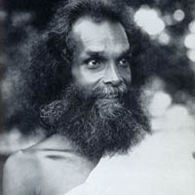
Shivapuri Baba 1826-1963
Senior Pediatrician Dr Yogendra Bhakta Shrestha, our guest speaker, shared his
experience and association with Saint Shivapuri Baba as his disciple until the
death of Baba in 1963 at the age of 137 yrs. He explained teachings of Baba on
three aspects of life : physical, moral and spiritual.
Shivapuri Baba
In 1844, at the age of eighteen, the future saint was ready to leave civilization and
attempt the vision of God. For the next quarter of a century, he lived alone in the
remote forest beside the Narbada river, in the upper Deccan of southern India.
What he was after, to be more precise, was ' Itambhara Prajna ', or complete union
with Absolute Will beyond Being itself. To achieve that, the young renunciate had
to live the minimum life possible so he could empty his mind of all its contents,
thereby enabling him to make that supreme act of total surrender and to remain in anxious suspension until the Breakthrough arrived.
And what a Breakthrough he had, after twenty-five years of non-stop practice, capped off by the crowning Touch of Divine Grace, the veil of consciousness was finally lifted, in a flash!, and he landed up in Eternity
As if that wasn't enough, after achieving the Impossible, the Saint then left the jungle, beaming radiant with the Light of God Realization, to perform the next activity on his list which just happened to be taking a walk around the entire world!

Weekly Meetings and Programs :
Date | Program/Speaker | Program/Topics of Presentation
17 February 2012 | Dr. Suman Thapa | Delivering Glaucoma Care in Nepal: A New Beginning

PRIP Glenn Estess passes away
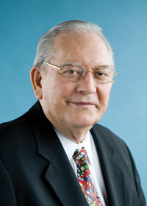
Glenn E. Estess Sr., who served as 2004-05 RI president during Rotary’s centennial year,
died on 7 February. He was 84. The passing away of PRIP Glenn has brought great sadness
and shock. He was a towering personality and his love for Rotarians in Nepal is well known.
It was during his tenure that Rotary International made the decision leading the way to the
creation of Nepal District 3292.
Heart-felt
CONDOLENCE
to all his near-and-dear ones


Past RI President Glenn Estess Sr. dies
Glenn E. Estess Sr., who served as 2004-05 RI president during Rotary’s centennial year, died on 7 February. He was 84.
In 1993, Estess retired as chief executive officer of Glenn Estess Associates Inc., a sales and marketing personnel consulting firm, to devote himself full-time to Rotary.
“I am sure the word most often used to describe Past President Glenn is ‘gentle,’” says Rotary Foundation Trustee Chair William B. Boyd. “He was strong in his beliefs but always gentle in expressing them and treated all people with respect and courtesy. He served the world through Rotary in many ways and always with a smile. The Rotary family will miss him. Our hearts go out to his wife, Mary.”
Estess, who joined Rotary in 1960, was a member of the Rotary Club of Shades Valley, Alabama, USA. In addition to his term as RI president, he served in numerous capacities including Rotary Foundation trustee chair, RI vice president and director, president’s aide, PolioPlus national coordinator, RI Audit and Operations Review Committee chair, International Assembly group discussion leader, and district governor.
He was a recipient of the RI Service Above Self Award and The Rotary Foundation’s Citation for Meritorious Service and Distinguished Service Award. He was a Foundation Major Donor, a Paul Harris Fellow, and benefactor.
Through the RI theme Celebrate Rotary , Estess encouraged clubs to implement a Rotary centennial community project, form twin club relationships, and support the Every Rotarian, Every Year effort, which aims to achieve an annual US$100 per capita contribution level for the Foundation’s Annual Fund.
“Glenn Estess had an uncomplicated but effective theme for Rotary’s centennial year,” says RI President Kalyan Banerjee. “He celebrated Rotary so aptly and simply during that year. It was amazing. Glenn was always humble, courteous, straightforward, and always doing the right thing.”
Estess served as president of the Birmingham Sales & Marketing Executives Association and the Alabama Association of Personnel Consultants.
Estess’ other accomplishments included director of Central Alabama Better Business Bureau; trustee chair of Baptist Medical Centers; chair of YMCA in Florida, the American Chemical Society, and the American Arthritis Foundation; and regent of the National Association of Personnel Consultants.
"The Four-Way Test was never a challenge for the lifestyle Glenn lived by. He embodied those values and set an example for so many Rotarians," says Donald E. Osburn, aide to the president during Estess’ term. "He always said Rotary is about making friendships for life and that’s exactly what he did all over the world."
He is survived by his wife, Mary; son Glenn Estess Jr.; and daughters Elizabeth Wilson and Nancy Martin.
Funeral services will be held on Friday, 10 February, at 1 p.m. at Brookwood Baptist Church, 3944 Overton Road, Birmingham, Alabama, 35223. Visitation will be held Thursday, 9 February, from 5 p.m. to 7 p.m. at the church.
In lieu of flowers, memorial contributions may be made to the Glenn E. Estess Sr. Endowed Scholarship Fund at The Rotary Foundation, either online or through an RI international office. Contributions may also be directed to the Glenn E. Estess Sr. Endowed Scholarship Fund, under the Foundation’s Permanent Fund.
Source: Ryan Hyland/Rotary International News

President’s condolence letter to DG
Dear DG Basudev:
Our Club meeting # 1118 held on Fri 10 Feb observed a minute of silence and expressed sorrow at the great loss of Past RI President Glenn Estess on Feb 7 at the age of 84.
We wished the departed soul peace and heart-felt condolences to RI community and his loved ones.
His contribution in helping us get our own District 3292 was noted with gratefulness.
YIR
Dr Som Pudasaini,
President, RC Kathmandu Mid-Town

Gorkha-Lamjung Girl Child project :
a) Scholarships/educational materials were distributed to 150 girl students of 7 schools of Dhuwakot VDC of Gorkha at Duvar Primary school on 4 Feb 2012.
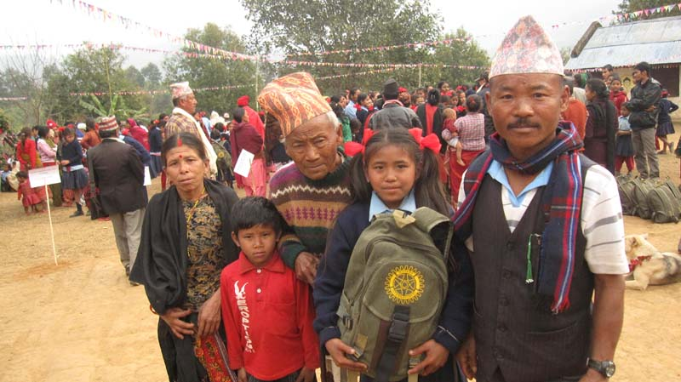
One girl student after receiving education materials posed for picture
with her parents and other family members.
b) Scholarships/educational materials were distributed to 152 Girl-Children of 4 schools of Lamjung Suryapal VDC at a function held at Sri Mangala High School, Sotipasal, on 5 Feb 2012.
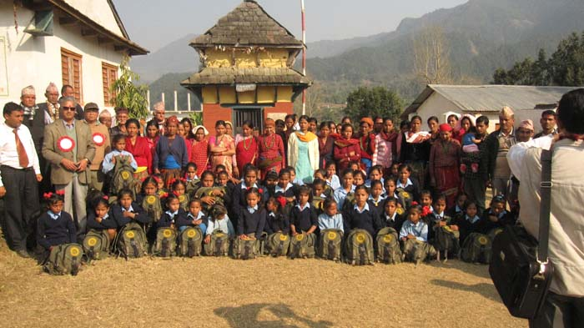
President Som and PP Arun posed for a picture with project/school officials and girl students receiving scholarships/education materials after the program.

Rotary South Asia Conference on Literacy:
Rotary South Asia Conference on Literacy is going to be held on 1-3 March 2012 at Hotel Hyatt, Kathmandu, Nepal to discuss the state of literacy, the shortcomings and the opportunities to work towards literacy.
This Conference will witness the presence and deliberations of extra-ordinary speakers, personalities and celebrities, international funding agencies, NGOs, government officials, politicians and other responsible stakeholders, including the Rotary leaders: RI President and RI Board of Directors, RI trustee's, chairperson besides others; to make the deliberations all encompassing and to assist in identifying the role of Rotary in promoting and enhancing literacy in South Asia.
More than two hundred Rotarian participants from India and other south Asian nations are expected to attend this Conference. RI District 3292 is the host to one of the most prestigious Rotary programs ever held in our country, and therefore, we all should put an effort to participate in the conference in as many numbers as we can in order to make this conference a grand success.
The registration fee for Nepalese Rotarians is Rs. 6500/- only per person which includes cocktails, two dinners and two lunches at hotel Hyatt. The registration should be completed by 25th of February and registration after that will cost Rs.7500/-.

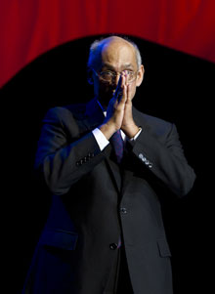
To achieve the fulfillment, we have to find harmony between our inner self and the outer
self; the inner dimensions are our desires, our will, our spirit, and our outer dimension is
the action we take and the image we create.
RI President Kalyan Banerjee

Please send project/activity information, suggestions and photos etc to :
BC Editor: RR Shrestha email: rryes@wlink.com.np

17 February 2012 The Weekly Bulletin of Rotary Club of Kathmandu Mid-Town bc-2.17/011-12

